Lab 6.4 Using Secrets

- Encode username and password
echo -n 'john@gmail.com' | base64
echo -n 'password' | base64

- Create a secrets.yml file as below:
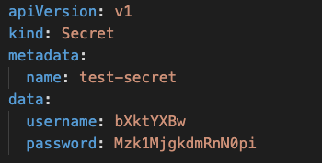

- Create the Secret
kubectl create -f secrets.yml

- Check the Secret that got created
kubectl get secrets
kubectl describe secret/creds-secret

- Create a pod-definition.yml file as below
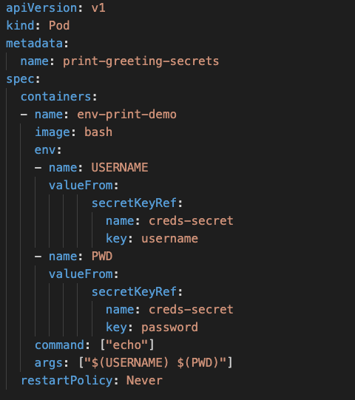

- Create the pod
kubectl create -f pod-definition.yml

- Check the Logs
kubectl logs -f print-greeting-secrets

- A pod can also access secrets data through a Volume. Create another pod using pod2-definition.yml file
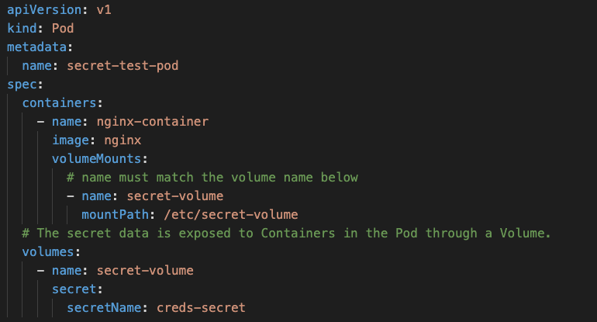

- Create the Pod
kubectl create -f pod2—definition.yml

- Check If the pod is created successfully
kubectl get pods

- Get a shell into the Container that is running in your Pod:
kubectl exec -it secret-test-pod -- /bin/bash

- The secret data is exposed to the Container through a Volume mounted under /etc/secret-volume. In your shell, list the files in the /etc/secret-volume directory:
ls /etc/secret-volume

- In your shell, display the contents of the username and password files:
echo "$( cat /etc/secret-volume/username )"
echo "$( cat /etc/secret-volume/password )"

